A

Project Report on

**Helping Hands**

Submitted in partial fulfilment of completion of the course

Advanced Diploma in IT, Networking and Cloud

Submitted by:

**Padam Singh**

**Nitin Punia**

**Deeksha Varshney**

**Sapna Kumari**

Under the Guidance of:

**(Edunet Mentor) Miss Mala Mishra**

|  |  |  |
| --- | --- | --- |
| IBM-Logo - Chicago Innovation | DGT introduces high end diploma courses - digitalLEARNING Magazine | Edunet Foundation-Delhi- CSR Organization profile |

Year 2023

# Abstract

The "**Helping** **Hands** Book Providing Organization for Education" is a nonprofit entity on a mission to revolutionize access to educational resources, one book at a time. Our organization recognizes the critical role that books play in shaping the minds and futures of students worldwide.

Our primary objective is to ensure that individuals, especially those in underserved communities, have ready access to a diverse range of books, fostering a lifelong love for learning and knowledge acquisition. We accomplish this through the collection, distribution, and donation of books to schools, libraries, and communities in need.

This abstract outline the core principles that guide our organization: the promotion of literacy, the cultivation of a reading culture, and the removal of barriers to educational attainment. We firmly believe that books are windows to the world, unlocking opportunities, broadening horizons, and nurturing critical thinking skills.

# Acknowledgement

We would like to express our sincere gratitude to several individuals and the IBM organization for supporting us throughout our diploma study. First, we wish to express our sincere gratitude to our Edunet mentor, **Miss. Mala Mishra**, for her enthusiasm, patience, insightful comments, helpful information, practical advice and unceasing ideas that have helped us tremendously at all times in our study and writing of this project report.

We also wish to express our sincere thanks to our T.O-Coordinator, **Mrs. Trupti Pawar** for her immense knowledge, profound experience and professional expertise in Industry has enabled us to complete this project successfully while making sure that it matched the industry standards.

I also own to my fellow friends & family who have been constant source of help to solve the problems and also helped me during the project development phase.

In addition, we are deeply indebted to the Ministry of Skill Development & Entrepreneurship and IBM for granting us the diploma course. Their technical and financial support has enabled us to complete our diploma course studies successfully.

# Team Composition and Workload Division

1. Padam Singh – UI (front-end), Design Patten, Page Layout, Database (backend) & Documentation.
2. Nitin Punia – UI (front-end) & Design Patten.
3. Deeksha Varshney – UI (front-end), Design Patten & Documentation.
4. Sapna Kumari – UI (front-end) & Design Patten.

|  |  |  |
| --- | --- | --- |
| Sr No | Table of Contents | Pages |
|  | Introduction to Problem | 6 |
|  | Literature Review | 7 |
|  | Proposed Solution | 8 |
|  | Requirements  4.1 Technology Stack  4.2 Hardware  4.3 Software  4.4 Deployment Environment | 9-11 |
|  | User Requirements | 12 |
|  | Design Documentation | 13 |
|  | Implementation Details | 14-15 |
|  | Testing | 16 |
|  | Deployment | 17-19 |
|  | Future Scope | 20 |
|  | Conclusion | 21 |
|  | Appendix A Project Code | 22-49 |
|  | Appendix B Screenshot of Project | 50-53 |
|  | Appendix C abbreviation | 54 |
|  | References | 55 |

1. **Introduction to Problem**

It appears you're looking for an NGO that provides books for 9th and 10th-grade students to address issues related to introductory topics or difficulties with certain subjects. While there may not be specific NGOs that cater exclusively to this niche, there are several educational NGOs and initiatives that focus on providing educational resources, including books, to students in need.

Our initiative, the "**Helping** **Hands**" is dedicated to ensuring that every 9th and 10th student has access to quality educational materials, particularly textbooks. We believe that access to these essential resources is a fundamental right and a crucial step toward a brighter future. Our project aims to bridge the educational resource gap by partnering with NGOs, schools, and publishers to provide free or affordable textbooks to students in need.

1. **Literature Review**

A literature review for an organization dedicated to providing books for education, such as the "**Helping** **Hands** Book Providing Organization for Education," would encompass a broad range of topics related to education, literacy, and the impact of book access on learning outcomes. Here's a brief literature review overview:

1. The Importance of Accessible Books in Education:

Numerous studies highlight the crucial role of accessible books in education. Research by Anderson et al. (2019) emphasizes that access to a variety of books is positively correlated with improved reading skills and academic achievement in students. This underscores the significance of organizations like Helping Hands in addressing educational disparities.

1. Educational Inequality and Book Access:

Work by Reardon (2018) and others reveals the persistent achievement gap in education, often driven by socio-economic disparities. Students from lower-income backgrounds tend to have limited access to books, which can lead to a lack of readiness for school. Helping Hand's mission to provide books to underserved communities directly addresses this issue.

1. Impact of Book Ownership on Literacy:

The study conducted by Neuman and Moland (2017) underscores the positive effects of book ownership on children's language development and literacy skills. This research highlights the potential long-term impact of organizations like Helping Hands, as they provide books that can become personal treasures for young learners.

1. Community and Family Engagement in Reading

Research by Sénéchal et al. (2017) indicates that family involvement in reading and access to books at home significantly benefit a child's early literacy development. The work of Helping Hands can be seen as an extension of this concept, as it aims to provide books not just to schools but also to communities and families.

1. Promoting a Reading Culture:

Organizations like Helping Hands contribute to fostering a culture of reading. The research by Krashen (2019) argues that voluntary reading, supported by access to a wide variety of books, can have a profound impact on vocabulary growth and academic achievement.

1. Measuring the Impact of Book Donation Programs:

Evaluating the effectiveness of book donation initiatives is essential. Studies like that of Burns et al. (2018) demonstrate the importance of monitoring and evaluating the outcomes of such programs to ensure that they meet their intended objectives and make a meaningful difference.

1. **Proposed Solution**

The proposed solution for the "**Helping** **Hands** Book Providing Organization for Education" entails a comprehensive approach to expand the organization's impact and address educational disparities. Firstly, strategic partnerships with publishers, educational institutions, and NGOs will be established to secure discounted or donated books and identify areas in dire need of resources. Recognizing the importance of digital resources, an online platform will be developed to provide e-books and other digital learning materials. Community outreach efforts will be strengthened, involving local communities in book donation drives and literacy events while establishing community libraries. Beyond book distribution, literacy programs, teacher training, and customized book selections will enhance the educational experience. A book tracking system will monitor the impact, and advocacy initiatives will promote policies supporting book provision and literacy programs. Sustainability practices, feedback mechanisms, and impact assessments will ensure the organization's continuous growth and success, ultimately contributing to a more literate and educated society.

1. **Requirements**
   1. **Technology Stack Full stack development**

Full stack development refers to the development of both front end (client side) and back end (server side) portions of web application. We have used

(HTML-CSS-JavaScript/Bootstrap at the front-end) & (Django Framework) as the database.

* 1. **Hardware**

• Desktop/Laptop

• Minimum 8GB RAM

• Processor 64-bit

• Solid State Drive 250GB

• Internet Connection

* 1. **Software**

**Front End**

**HTML:**

Hyper Text Markup Language (HTML) is a markup language for creating a webpage. Webpages are usually viewed in a web browser. They can include writing, links, pictures, and even sound and video. HTML is used to mark and describe each of these kinds of content so the web browser can display them correctly.

**CSS:**

CSS is the language for describing the presentation of Web pages, including colours, layout, and fonts. It allows one to adapt the presentation to different types of devices, such as large screens, small screens, or printers. CSS is independent of HTML and can be used with any XML-based markup language.

**JavaScript:** JavaScript is a lightweight, interpreted programming language. It is designed for creating network-centric applications. It is complimentary to and integrated with Java. JavaScript is very easy to implement because it is integrated with HTML. It is open and cross-platform. It is the most popular programming language in the world and that makes it a programmer’s great choice. Once you learnt JavaScript, it helps you developing great front-end as well as back-end software’s using different JavaScript based frameworks like jQuery, Node.JS etc.

**Bootstrap**: Bootstrap is a popular open-source front-end framework for building websites and web applications. It was originally developed by Twitter and is now maintained by a community of developers. Bootstrap provides a set of pre-designed HTML, CSS, and JavaScript components and templates that make it easier to create responsive and visually appealing web pages. It includes things like navigation bars, buttons, forms, grids, and more, which can be customized and integrated into web projects. By using Bootstrap, developers can save time and ensure their websites are mobile-friendly and well-designed.

**jQuer**y: jQuery is a widely-used JavaScript library that streamlines web development on the client-side. Created by John Resig in 2006, jQuery simplifies various aspects of web development, including DOM manipulation, event handling, AJAX requests, animations, and cross-browser compatibility. With its intuitive syntax and consistent API, developers can easily select and manipulate HTML elements, attach event listeners, and create interactive web pages. jQuery's built-in features make it an invaluable tool for enhancing user experiences and building responsive web applications. Its lightweight nature, coupled with a vast ecosystem of community-developed plugins, has solidified its place in modern web development, offering a powerful and efficient way to create dynamic and visually appealing websites.

**Back End**

**Django:** Django is a high-level Python web framework designed specifically for backend development. It provides a robust and comprehensive toolkit for building web applications and APIs with ease and efficiency. Django follows the "batteries-included" philosophy, which means it comes with a wide range of built-in features and modules for common web development tasks, such as database management, user authentication, URL routing, and template rendering. This feature-rich framework encourages developers to follow best practices and maintain a clean and organized codebase.

One of Django's key strengths is its focus on security. It incorporates security features like protection against common web vulnerabilities (e.g., Cross-Site Scripting and SQL injection) by default, helping developers build secure applications. Additionally, Django's Object-Relational Mapping (ORM) system simplifies database interactions, making it possible to work with various databases without needing to write raw SQL queries**.**

Django also supports the creation of reusable applications and encourages the use of the DRY (Don't Repeat Yourself) principle, which leads to more maintainable and scalable code. Its templating engine allows for the separation of logic and presentation, facilitating clean and maintainable code.

**PostgreSQL:** PostgreSQL, often referred to as "Postgres," is a powerful open-source relational database management system (RDBMS). It is known for its robustness, extensibility, and adherence to SQL standards. PostgreSQL is widely used in both small and large-scale applications and is considered one of the most advanced open-source database systems available.

Here are some key features and aspects of PostgreSQL:

* Open Source: PostgreSQL is released under the PostgreSQL License, a permissive open-source license, which allows users to use, modify, and distribute it freely.
* Relational Database: It is a relational database system, meaning it organizes data into tables with rows and columns and supports SQL for data manipulation and querying.
  1. **Deployment Environment**

**Vercel**

Vercel is a cloud platform known for its ease of use in deploying web applications, including Django projects. While it's primarily designed for static sites and serverless functions, it can host Django apps effectively through serverless functions and APIs. Vercel offers seamless integration with popular version control systems like Git and provides a robust CI/CD pipeline. Developers can take advantage of its global CDN for content delivery, automatic HTTPS, and scalability. Although unconventional for Django, Vercel's flexibility and simplicity make it a viable option, especially for smaller projects or components of larger applications, thanks to its serverless capabilities.

1. **User Requirements**

• Electronic Device: Mobile, Laptop, Desktop or Tablet

• Email Account

• Access to Internet

**6. Design Documentation**

**6.1 Data Flow Diagram**

**Diagram 1**

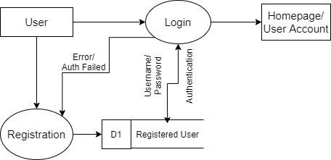

**6.2 ER Diagram Helping Hands**

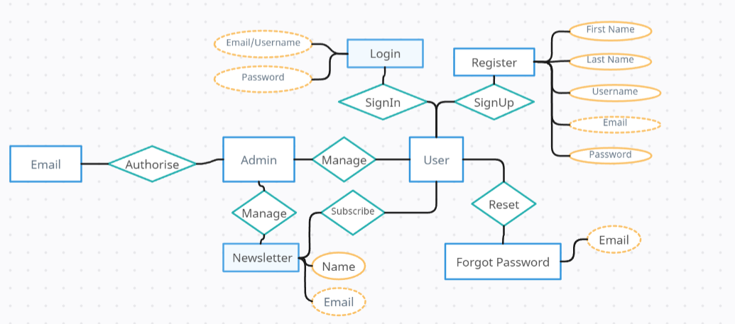

1. **Implementation Details**
   1. **Login Page** In this module, you can login into the account registered on the website using your email/username id and password.
   2. **Registration Page** On the registration page, you can create a user account if you haven't already. You'll be asked to provide your first name, last name, username, email, and password. Once you submit this information, it will be securely stored in our database, and your account will be successfully created. You can then log in using your email and password whenever you need access.
   3. **Home Page** Welcome to our **Helping** **Hands** NGO! We are dedicated to making a positive impact in our community. Explore our website to learn more about our services, meet our passionate team members, discover our mission and partners, join us in our cause, and get in touch with us. Together, we can create a better world.

This content briefly introduces your NGO and highlights the main sections available in your navigation menu: Home, Service, Members, About, Join Us, and Contact. You can expand upon each section's details on their respective pages.

* 1. **Service Page** Welcome to our Service page, where students in the 9th and 10th grades can access high-quality textbooks. We are committed to supporting your education by offering a range of affordable and essential books tailored to your curriculum. Our carefully curated selection ensures that you have the resources you need to excel academically. Ordering is straightforward - browse our catalogue, select your required books, and complete the purchase. At Helping Hands NGO, we believe that education should be accessible to all, and our book service is designed with your learning journey in mind. Start exploring and investing in your future today.
  2. **Members Page** Get to know the heart and soul of our NGO – our dedicated members. On this page, we introduce you to the passionate individuals who drive our mission forward. Each member shares their thoughts, insights, and experiences in making a positive impact on our community. Discover the diverse perspectives that shape our work.

Meet our members from various cities who are committed to creating a better world. From their unique vantage points across the globe, they share their stories, ideas, and visions for a brighter future. Explore the voices of change and be inspired by the collective efforts of our community members.

* 1. **About Page** Our mission is rooted in the belief that even small actions can lead to significant transformations. Through various initiatives, we strive to address pressing issues such as education, healthcare, and social welfare. We are driven by the conviction that together we can build a brighter and more inclusive future for all.Our dedicated team, passionate volunteers, and valued partners work tirelessly to bring our vision to life. Join us on this journey of compassion and change. Together, we can make a difference that lasts a lifetime.
  2. **Join Us** We are grateful for your willingness to contribute to our mission. Your donation enables us to extend our reach and impact. On this page, you can make a meaningful difference.

Use the form below to securely submit your donation. Whether it's a one-time gift or a recurring contribution, every bit counts. Your support helps us drive change in education, healthcare, and community welfare.

For added convenience, you can also scan the QR code to make a quick and easy donation. Your generosity fuels our work, and we are truly thankful for your support. Together, we can create a brighter future for those in need.

* 1. **Contact Page** Your feedback and inquiries are important to us. Use the form below to reach out, and we'll get back to you promptly. Whether you have questions, suggestions, or want to explore collaboration opportunities, we're here to assist.

Simply fill in the required fields, and your message will be on its way to us. Your communication helps us better understand your needs and improve our efforts. Thank you for taking the time to connect with us. We look forward to hearing from you and working together to make a positive impact

1. **Testing**

Web application refers to all applications that are accessed through a browser. This section outlines some of the testing methodologies you can use to test your web applications.

1. **Usability testing** Usability Testing also known as User Experience (UX) Testing, is a testing method for measuring how easy and user-friendly a software application is. A small set of target end-users, use software application to expose usability defects. Usability testing mainly focuses on user's ease of using application, flexibility of application to handle controls and the ability of application to meet its objectives.
2. **User acceptance testing** The objective of user acceptance testing is to make sure your application meets the expectations of the user. It ensures that the application is fit enough to be deployed and used effectively.
3. **Unit Testing** Unit testing is a software testing method by which individual units of source code—sets of one or more computer program modules together with associated control data, usage procedures, and operating procedures—are tested to determine whether they are fit for use.
4. **Deployment**

Step 1. We need to create a **vercel.json** file in our Django folder (Our project folder name is django_website) and write this code inside the vercel.json.

|  |
| --- |
| {  "builds": [{  "src": "django_website/wsgi.py",  "use": "@vercel/python",  "config": { "maxLambdaSize": "15mb", "runtime": "python3.9" }  },  {  "src": "build_files.sh",  "use": "@vercel/static-build",  "config": { "distDir": "staticfiles_build" }  }],  "routes": [  {  "src": "/static/(.*)",  "dest": "/static/$1"  },  {  "src": "/(.*)",  "dest": "django_website/wsgi.py"  }  ]  } |

**Step 2.** Now create a build_files.sh file in our Django folder and write this code inside the build_files.sh.

|  |
| --- |
| echo "BUILD START"  python3.9 -m pip install -r requirements.txt  python3.9 manage.py collectstatic --noinput --clear  echo "BUILD END" |

Step 3. Now create a requirements.txt file in our Django folder and write this code inside the requirements.txt.

|  |
| --- |
| Django==4.2.5  django-allauth==0.57.0  django-tinymce==3.6.1  django-recaptcha==3.0.0  drf-yasg==1.21.5  #psycopg2==2.9.5  psycopg2-binary==2.9.5  six==1.16.0 |

Step 4. Write some code inside the setting.py.

|  |
| --- |
| import os  ALLOWED_HOSTS = ['*']  DATABASES = {  'default': {  'ENGINE': 'django.db.backends.postgresql',  'NAME': 'railway',  'USER': 'postgres',  'PASSWORD': 'Your database password',  'HOST': 'Your host',  'PORT': '7168',  }  }  STATIC_ROOT = os.path.join(BASE_DIR, 'staticfiles_build', 'static')  MEDIA_URLS ='/media/'  MEDIA_ROOT = os.path.join(BASE_DIR, 'media') |

Step 5. Open the wsgi.py and write this line inside the file.

|  |
| --- |
| application = get_wsgi_application()  app= application |

Step 6. Go to the terminal and run the command py manage.py makemigrations and py manage.py migrate and hit enter.

Step 7. Upload your file on GitHub.

Step 8. Go the vercel website and create a account.

Step 9. Connect your vercel to GitHub.

Step 10. Now create a new Project on vercel web site and click on import.

|  |
| --- |
|  |

Step 11. Give the Project name and just click on deploy. After some time later you get a link.

|  |
| --- |
|  |

**10. Future Scope**

The project has a very vast scope in future. It can be updated in near future as and when requirement for the same arises, as it is very flexible in terms of expansion. The following are the future scope for the project:

1. Collaboration with Government of India, Department of Post for the free shipping and pick up of the books.
2. Adding a payment method suitably.
3. Adding crowdfunding to purchase the unavailable books.
4. Adding options of Issuing Engineering, Degree and etc. books.

**11. Conclusion**

In conclusion, the "**Helping** **Hands** Book Providing Organization for Education" stands as a beacon of hope in the pursuit of educational equity and literacy enhancement. Through an array of strategic initiatives, this organization is poised to make a lasting impact on the lives of countless students and communities. By forging partnerships, embracing digital resources, and fostering community engagement, it will expand its reach and amplify its influence. The commitment to not only distributing books but also nurturing a reading culture and providing holistic educational support underscores the organization's dedication to creating a brighter future for all. As it implements sustainable practices, monitors impact, and advocates for systemic change, the **Helping** **Hands** Book Providing Organization for Education is not only a provider of books but also a catalyst for transformation in the world of education. Its tireless efforts will continue to bridge the gap in educational opportunities, empowering individuals to unlock their full potential through the gift of knowledge. In this way, the organization leaves an indelible mark on the path toward a more literate, inclusive, and prosperous society.

# Appendix A

**Project Code**

**Index.html**

**django_website/main/templates/index.html**

|  |
| --- |
| {% extends 'base.html' %}  {% block title %} Home {% endblock title %}  {% block body %}  <aside id="fh5co-hero">  <div class="flexslider">  <ul class="slides">  <li style="background-image: url(static/image/slide2.png); background-size: cover;">  <div class="overlay-gradient"></div>  <div class="container">  <div class="row">  <div class="col-md-8 col-md-offset-2 text-center slider-text">  <div class="slider-text-inner ">  <h1>Population, unemployment or pollution, Education is all problem’s solution.  </h1>  <h2>Brought to you by <a href="" target="_blank">Helping Hands</a></h2>  <a href="JoinUs">  <button class="learn-more button-bt">  <span class="circle" aria-hidden="true">  <span class="icon arrow"></span>  </span>  <span class="button-text"  style="padding-left: 2px; padding-top: 5px; font-size: small;">Join  Us</span>  </button>  </a>  </div>  </div>  </div>  </div>  </li>  <li style="background-image: url(static/image/inst2.jpg); background-size: cover;">  <div class="overlay-gradient"></div>  <div class="container">  <div class="row">  <div class="col-md-8 col-md-offset-2 text-center slider-text">  <div class="slider-text-inner ">  <h1>Girls or boys; male or female, all have equal rights to education!</h1>  <h2>Brought to you by <a href="" target="_blank">Helping Hands</a></h2>  <a href="JoinUs">  <button class="learn-more button-bt">  <span class="circle" aria-hidden="true">  <span class="icon arrow"></span>  </span>  <span class="button-text"  style="padding-left: 2px; padding-top: 5px; font-size: small;">Join  Us</span>  </button>  </a>  </div>  </div>  </div>  </div>  </li>  <li style="background-image: url(static/image/slide03.jpg); background-size: cover;">  <div class="overlay-gradient"></div>  <div class="container">  <div class="row">  <div class="col-md-8 col-md-offset-2 text-center slider-text">  <div class="slider-text-inner ">  <h1>Education is a best tool, creates difference between wise and fool.</h1>  <h2>Brought to you by <a href="" target="_blank">Helping Hands</a></h2>  <a href="JoinUs">  <button class="learn-more button-bt">  <span class="circle" aria-hidden="true">  <span class="icon arrow"></span>  </span>  <span class="button-text"  style="padding-left: 2px; padding-top: 5px; font-size: small;">join  Us</span>  </button>  </a>  </div>  </div>  </div>  </div>  </li>  </ul>  </div>  </aside>  <div class="container">  <div class="row animate-box">  <div class="col-md-8 col-md-offset-2 text-center fh5co-heading">  <h4 style=" text-align: justify;">NGOs (Non-Governmental Organizations) play a crucial role in promoting education and  addressing educational challenges worldwide. Education is a fundamental human right and a key driver of personal  and societal development.  Here are some key thoughts and considerations regarding the role of NGOs in education  Helping Hands flagship programme Mission Education works with the objective of empowering underprivileged  children by providing education, nutrition, and wellness support. The programme is well aligned to the New  Education Policy (2020), and the SDG Goal 4 (Ensure inclusive and equitable quality education and promote  lifelong learning opportunities for all). Mission Education works with children (3-18 years) living in  difficult circumstances, children from poor families, differently abled children,  disaster-struck children, abandoned and street children, and children living in tribal belts,  remote villages and hard to reach areas.</h4>  <h4 style=" text-align: justify;">Helping Hands works as a catalyst in the cycle of change, complementing and supplementing  government efforts (view details) to achieve the Sustainable Development Goals. We sensitize and  partner with like-minded institutions and individuals to implement high-impact programmes that  enable access, enhance quality and help bring long term behavioural change at the grassroots.  </h4>  </div>  </div>  </div>  <div id="fh5co-counter" class="fh5co-counters" style="background-image: url(static/image/slide5.jpeg);"  data-stellar-background-ratio="0.5">  <div class="overlay"></div>  <div class="container">  <div class="row animate-box">  <div class="col-md-8 col-md-offset-2 text-center fh5co-heading">  <h2 style="color: white;">FOLLOW US</h2>  <div style="display: flex; justify-content: center;">  <a href="https://www.facebook.com/HelpingHandsOfficaial/">  <div style="margin-left: 20px; margin-right: 20px">  <!-- Button 1 -->  <!-- ... (your code for button 1) ... -->  <button class="Btn">  <span class="svgContainer">  <svg fill="white" class="svgIcon" viewBox="0 0 320 512" height="1.5em" xmlns="http://www.w3.org/2000/svg">  <path  d="M300 32H20C8.954 32 0 40.954 0 52v416c0 11.046 8.954 20 20 20h152V332h-44v-64h44V180c0-43.882 35.118-80 79-80h48v64h-36c-13.255 0-24 10.745-24 24v44h60.474l-8 64H268v148h52c11.046 0 20-8.954 20-20V52c0-11.046-8.954-20-20-20z" />  </svg>  </span>  <span class="BG-facebook"></span>  </button>  </div>  </a>  {% comment %} s {% endcomment %}  <a href="https://www.instagram.com/_.helping___hands/">  <div style="margin-left: 20px; margin-right: 20px">  <!-- Button 3 -->  <!-- ... (your code for button 3) ... -->  <button class="Btn">  <span class="svgContainer">  <svg fill="white" class="svgIcon" viewBox="0 0 448 512" height="1.5em" xmlns="http://www.w3.org/2000/svg">  <path  d="M224.1 141c-63.6 0-114.9 51.3-114.9 114.9s51.3 114.9 114.9 114.9S339 319.5 339 255.9 287.7 141 224.1 141zm0 189.6c-41.1 0-74.7-33.5-74.7-74.7s33.5-74.7 74.7-74.7 74.7 33.5 74.7 74.7-33.6 74.7-74.7 74.7zm146.4-194.3c0 14.9-12 26.8-26.8 26.8-14.9 0-26.8-12-26.8-26.8s12-26.8 26.8-26.8 26.8 12 26.8 26.8zm76.1 27.2c-1.7-35.9-9.9-67.7-36.2-93.9-26.2-26.2-58-34.4-93.9-36.2-37-2.1-147.9-2.1-184.9 0-35.8 1.7-67.6 9.9-93.9 36.1s-34.4 58-36.2 93.9c-2.1 37-2.1 147.9 0 184.9 1.7 35.9 9.9 67.7 36.2 93.9s58 34.4 93.9 36.2c37 2.1 147.9 2.1 184.9 0 35.9-1.7 67.7-9.9 93.9-36.2 26.2-26.2 34.4-58 36.2-93.9 2.1-37 2.1-147.8 0-184.8zM398.8 388c-7.8 19.6-22.9 34.7-42.6 42.6-29.5 11.7-99.5 9-132.1 9s-102.7 2.6-132.1-9c-19.6-7.8-34.7-22.9-42.6-42.6-11.7-29.5-9-99.5-9-132.1s-2.6-102.7 9-132.1c7.8-19.6 22.9-34.7 42.6-42.6 29.5-11.7 99.5-9 132.1-9s102.7-2.6 132.1 9c19.6 7.8 34.7 22.9 42.6 42.6 11.7 29.5 9 99.5 9 132.1s2.7 102.7-9 132.1z">  </path>  </svg>  </span>  <span class="BG-instagram"></span>  </button>  </div>  </a>  {% comment %}  <a href="https://www.linkedin.com/in/padam-singh-015164257/">  <div style="margin-left: 20px; margin-right: 20px">  <!-- Button 4 -->  <!-- ... (your code for button 4) ... -->  <button class="Btn">  <span class="svgContainer">  <svg fill="#0e76a8" class="svgIcon" viewBox="0 0 448 512" height="1.5em"  xmlns="http://www.w3.org/2000/svg">  <path  d="M416 32H31.9C14.3 32 0 46.5 0 64.3v383.4c0 17.7 14.3 32.3 31.9 32.3H416c17.6 0 32-14.5 32-32.3V64.3C448 46.6 433.6 32 416 32zM135 396H69V209h66v187zm-33-207c-22 0-40-18-40-40s18-40 40-40 40 18 40 40-18 40-40 40zm267 207h-66V293c0-24-9-45-28-45s-33 21-33 45v109h-66V209h66v29c9-18 32-37 63-37 69 0 82 45 82 103v139z" />  </svg>  </span>  <span class="BG-linkdin"></span>  </button>  </div>  </a> {% endcomment %}  {% comment %}  <a href="https://twitter.com/Padamsi42039687">  <div style="margin-left: 20px; margin-right: 20px">  <!-- Button 5 -->  <!-- ... (your code for button 5) ... -->  <button class="Btn">  <span class="svgContainer">  <svg fill="#1DA1F2" class="svgIcon" viewBox="0 0 512 512" height="1.5em"  xmlns="http://www.w3.org/2000/svg">  <path  d="M437.4 152.3c.3 4.2.3 8.4.3 12.6 0 128.7-98 277-277 277-55 0-105.9-16-149.1-43.8 7.8.9 15.8 1.4 24 1.4 47 0 90.1-16 124.5-43-43.8-.9-80.7-29.6-93.4-69.3 6 .9 11.8 1.4 18.2 1.4 8.9 0 17.7-1.4 25.9-3.7-45.4-9.2-79.5-49.1-79.5-96.8v-1.3c13.3 7.4 28.6 11.8 44.8 12.3-26.5-17.7-43.8-47.6-43.8-81.7 0-18.5 4.7-35.6 13-50.4 47.5 58.3 118.2 96.8 197.8 100.9-1.6-7.8-2.3-15.8-2.3-23.8 0-57.3 46.4-103.8 103.8-103.8 29.6 0 56.5 12.3 75.3 32.2 23.4-4.7 45.4-13 65-24.7-7.8 24.7-24.7 45.4-46.1 58.8 21.2-2.3 41.2-8.9 59.6-18.5-14.1 20.5-31 38.2-50.4 52.6z" />  </svg>  </span>  <span class="BG-twitter"></span>  </button>  </div>  </a> {% endcomment %}  </div>  </div>  </div>  </div>  </div>  </div>  <div id="fh5co-course-categories">  <div class="container">  <div class="row animate-box">  <div class="col-md-6 col-md-offset-3 text-center fh5co-heading">  <h2>OUR PROGRAMMES</h2>  <p></p>  </div>  </div>  <div class="row">  <div class="col-md-4 col-sm-6 text-center animate-box">  <div class="services">  <span class="icon">  <i><img src="static/image/education.webp" alt="" srcset="" style="width: 50px;"></i>  </span>  <div class="desc">  <h3><a  style="color: #f0c774; text-transform: uppercase; text-decoration: underline;">Education</a>  </h3>  <p>Education, nutrition and holistic development of children</p>  </div>  </div>  </div>  {% comment %} <div class="col-md-3 col-sm-6 text-center animate-box">  <div class="services">  <span class="icon">  <i><img src="static/image/women.webp" alt="" srcset="" style="width: 50px;"></i>  </span>  <div class="desc">  <h3><a href="#"  style="color: #b3d2d1; text-transform: uppercase; text-decoration: underline;">Women  Empowerment</a></h3>  <p>Empowering adolescent girls & women through community engagement</p>  <p>In Future</p>  </div>  </div>  </div> {% endcomment %}  <div class="col-md-4 col-sm-6 text-center animate-box">  <div class="services">  <span class="icon">  <i><img src="static/image/healthcare.webp" alt="" srcset="" style="width: 50px;"></i>  </span>  <div class="desc">  <h3><a  style="color: #c0adcc; text-transform: uppercase; text-decoration: underline;">Healthcare</a>  </h3>  <p>Taking healthcare services to doorsteps of hand to reach communities</p>  <p>In Future</p>  </div>  </div>  </div>  <div class="col-md-4 col-sm-6 text-center animate-box">  <div class="services">  <span class="icon">  <i><img src="static/image/livelihood.webp" alt="" srcset="" style="width: 50px;"></i>  </span>  <div class="desc">  <h3><a  style="color: #debfae; text-transform: uppercase; text-decoration: underline;">Livelihood</a>  </h3>  <p>Skill training and placement support for underprivileged youth</p>  <p>In Future</p>  </div>  </div>  </div>  </div>  </div>  </div>  <div id="fh5co-counter" class="fh5co-counters" style="background-image: url(static/image/slide5.jpeg);"  data-stellar-background-ratio="0.5">  <div class="overlay"></div>  <div class="container">  <div class="row animate-box">  <div class="col-md-8 col-md-offset-2 text-center fh5co-heading">  <h2 style="color: white;">OUR IMPACT</h2>  </div>  </div>  <div class="row">  <div class="col-md-10 col-md-offset-1">  <div class="row">  <div class="col-md-3 col-sm-6 text-center animate-box">  <span class="icon"><i class="icon-world"></i></span>  <span class="fh5co-counter js-counter" data-from="0" data-to="200" data-speed="5000"  data-refresh-interval="50"></span>  <span class="fh5co-counter-label">VILLAGES</span>  </div>  <div class="col-md-3 col-sm-6 text-center animate-box">  <span class="icon"><i class="icon-study"></i></span>  <span class="fh5co-counter js-counter" data-from="0" data-to="3700" data-speed="5000"  data-refresh-interval="50"></span>  <span class="fh5co-counter-label">CHILDRENS</span>  </div>  <div class="col-md-3 col-sm-6 text-center animate-box">  <span class="icon"><i class="icon-bulb"></i></span>  <span class="fh5co-counter js-counter" data-from="0" data-to="100" data-speed="5000"  data-refresh-interval="50"></span>  <span class="fh5co-counter-label">PROJECTS</span>  </div>  <div class="col-md-3 col-sm-6 text-center animate-box">  <span class="icon"><i class="icon-head"></i></span>  <span class="fh5co-counter js-counter" data-from="0" data-to="25" data-speed="5000"  data-refresh-interval="50"></span>  <span class="fh5co-counter-label">STATES</span>  </div>  </div>  </div>  </div>  </div>  </div>  <div id="fh5co-course-categories">  <div class="container">  <div class="row animate-box">  <div class="col-md-6 col-md-offset-3 text-center fh5co-heading">  <h1>TOWARDS ACHIEVING</h1>  <h2>SUSTAINABLE DEVELOPMENT GOALS</h2>  </div>  </div>  <div class="row">  <div class="col-md-2 col-sm-6 text-center animate-box">  <div class="services">  <span>  <i><img src="static/image/good-health.webp" alt="" srcset="" style="width: 195px;"></i>  </span>  </div>  </div>  <div class="col-md-2 col-sm-6 text-center animate-box">  <div class="services">  <span>  <i><img src="static/image/gender-equality.webp" alt="" srcset=""  style="width: 195px;"></i>  </span>  </div>  </div>  <div class="col-md-2 col-sm-6 text-center animate-box">  <div class="services">  <span>  <i><img src="static/image/quality-education-copy.webp" alt="" srcset=""  style="width: 195px;"></i>  </span>  </div>  </div>  <div class="col-md-2 col-sm-6 text-center animate-box">  <div class="services">  <span>  <i><img src="static/image/economic-growth.webp" alt="" srcset=""  style="width: 195px;"></i>  </span>  </div>  </div>  <div class="col-md-2 col-sm-6 text-center animate-box">  <div class="services">  <span>  <i><img src="static/image/reduced-copy.webp" alt="" srcset="" style="width: 195px;"></i>  </span>  </div>  </div>  <div class="col-md-2 col-sm-6 text-center animate-box">  <div class="services">  <span>  <i><img src="static/image/partnership.webp" alt="" srcset="" style="width: 195px;"></i>  </span>  </div>  </div>  </div>  </div>  </div>  <div id="fh5co-course">  <div class="container">  <div class="row animate-box">  <div class="col-md-6 col-md-offset-3 text-center fh5co-heading">  <h2>Support A Cause</h2>  </div>  </div>  <div class="row">  <div class="col-md-6 animate-box">  <div class="course">  <a class="course-img" style="background-image: url(static/image/girl.jpg);">  </a>  <div class="desc">  <h3><a>TAYYARI KAL KI</a></h3>  <p>Our campaign ‘Tayyari Kal Ki’ aims at Training & Up Skilling the youth between the  age of 18-32 years for employment and empowering them with a secure livelihood.  </p>  <span><a href="SupportACause">  <button class="learn-more button-bt">  <span class="circle" aria-hidden="true">  <span class="icon arrow"></span>  </span>  <span class="button-text"  style="padding-left: 8px; padding-top: 5px; font-size: small;">Learn  More</span>  </button>  </a></span>  </div>  </div>  </div>  <div class="col-md-5 animate-box">  <div class="course">  <a class="course-img" style="background-image: url(static/image/girl2.jpg);">  </a>  <div class="desc">  <h3><a >HEALTH  CANNOT WAIT</a></h3>  <p>  Realising the need for accessible and quality healthcare for all, our campaign  ‘Health Cannot Wait’ aims at providing people from the under-privileged sections  </p>  <span><a href="SupportACause">  <button class="learn-more button-bt">  <span class="circle" aria-hidden="true">  <span class="icon arrow"></span>  </span>  <span class="button-text"  style="padding-left: 8px; padding-top: 5px; font-size: small;">Learn  More</span>  </button>  </a></span>  </div>  </div>  </div>  <div class="col-md-6 animate-box">  <div class="course">  <a class="course-img" style="background-image: url(static/image/boy1.jpg);">  </a>  <div class="desc">  <h3><a >SHIKSHA  NA RUKE</a></h3>  <p>  Helping Hands, through its ‘Shiksha Na Ruke’ initiative, has been helping  children from difficult circumstances get back to school and restart their lives  </p>  <span><a href="SupportACause">  <button class="learn-more button-bt">  <span class="circle" aria-hidden="true">  <span class="icon arrow"></span>  </span>  <span class="button-text"  style="padding-left: 8px; padding-top: 5px; font-size: small;">Learn  More</span>  </button>  </a></span>  </div>  </div>  </div>  <div class="col-md-6 animate-box">  <div class="course">  <a class="course-img" style="background-image: url(static/image/girl3.jpg);">  </a>  <div class="desc">  <h3><a >SHE CAN  FLY</a></h3>  <p>SHE CAN  FLY  Helping Hands initiative ‘She Can Fly’ is an effort to enable, equip and  empower girl children with quality education, proper nutrition, good health  </p>  <span><a href="SupportACause">  <button class="learn-more button-bt">  <span class="circle" aria-hidden="true">  <span class="icon arrow"></span>  </span>  <span class="button-text"  style="padding-left: 8px; padding-top: 5px; font-size: small;">Learn  More</span>  </button>  </a></span>  </div>  </div>  </div>  </div>  </div>  </div>  <div id="fh5co-blog">  <div class="container">  <div class="row animate-box">  <div class="col-md-8 col-md-offset-2 text-center fh5co-heading">  <h2>Events</h2>  <p>Helping Hand NGO orchestrates impactful events, rallying volunteers for social good. From  educational workshops and environmental cleanups to fundraisers for underprivileged  communities, their events ignite positive change. Through collaborative efforts, Helping  Hand's events inspire a brighter future while addressing pressing issues with compassion and  dedication.</p>  </div>  </div>  <div class="row row-padded-mb">  <div class="col-md-4 animate-box">  <div class="fh5co-event">  <div class="date text-center"><span>15<br>Sept.</span></div>  <h3><a href="SupportACause">TAYYARI KAL KI</a></h3>  <a href="https://goo.gl/maps/CpCTcAseGr5G28p99" target="_blank" rel="noopener noreferrer"><div class="loader-location"></div></a>  <p style="margin-top: -40px; margin-left: 50px;">SSSB Block, Nand Nagri, New Delhi, East Delhi, Delhi-110093</p>  </div>  </div>  <div class="col-md-4 animate-box">  <div class="fh5co-event">  <div class="date text-center"><span>25<br>Oct.</span></div>  <h3><a href="SupportACause">HEALTH CANNOT WAIT</a></h3>  <a href="https://goo.gl/maps/CpCTcAseGr5G28p99" target="_blank" rel="noopener noreferrer"><div class="loader-location"></div></a>  <p style="margin-top: -40px; margin-left: 50px;">SSSB Block, Nand Nagri, New Delhi, East Delhi, Delhi-110093</p>  </div>  </div>  <div class="col-md-4 animate-box">  <div class="fh5co-event">  <div class="date text-center"><span>05<br>Dec.</span></div>  <h3><a href="SupportACause">SHIKSHA NA RUKE</a></h3>  <a href="https://goo.gl/maps/CpCTcAseGr5G28p99" target="_blank" rel="noopener noreferrer"><div class="loader-location"></div></a>  <p style="margin-top: -40px; margin-left: 50px;">SSSB Block, Nand Nagri, New Delhi, East Delhi, Delhi-110093</p>  </div>  </div>  </div>  </div>  </div>  {% endblock body %} |

**login.html**

**django_website/users/templates/users/login.html**

|  |
| --- |
| {% extends 'baselogin.html' %}  {% block title %} Home {% endblock title %}  {% block body %}  <!DOCTYPE html>  <html lang="en">  <head>  <meta charset="UTF-8">  <meta name="viewport" content="width=device-width, initial-scale=1.0">  <title>Login</title>  <!-- Link Bootstrap CSS -->  <link rel="stylesheet" href="https://stackpath.bootstrapcdn.com/bootstrap/4.5.2/css/bootstrap.min.css">  <style>    body {  padding: 0px;  margin: 0px;  {% comment %} overflow-y: hidden; {% endcomment %}  }  .registration-container {  display: flex;  justify-content: center;  align-items: center;  height: 100vh;  }  .video-container {  flex: 1;  overflow: hidden;  position: relative;  }  .registration-form {  flex: 3; /* 75% width for the form */  padding: 20px;  background-color: #f8f9fa;  }  .video {  position: relative;  top: 0;  left: 0;  width: 100%;  height: 100%;  object-fit: cover;  }  .logo {  position: absolute;  top: 20px;  left: 20px;  width: 100px; /* Adjust logo width as needed */  height: auto;  z-index: 1; /* Ensure logo is above video */  }  /* form css Start */  .form-container {  width: 550px;    padding: 32px 24px;  font-size: 14px;  font-family: inherit;  color: #212121;  display: flex;  flex-direction: column;  gap: 24px;  box-sizing: border-box;    }  .form-container button:active {  scale: 0.95;  }  .form-container .logo-container {  margin-bottom: 12px;  text-align: center;  font-weight: 700;  font-size: 20px;  }  .form-container .social-buttons {  display: flex;  justify-content: center;  margin-bottom: 20px;  flex-direction: column;  gap: 12px;  align-items: center;  }  .form-container .social-button {  display: flex;  justify-content: center;  align-items: center;  width: 100%;  font-family: inherit;  color: #fff;  border: none;  padding: 12px 16px;  gap: 8px;  cursor: pointer;  border-radius: 6px;  box-shadow: 0px 0px 3px rgba(0, 0, 0, 0.084), 0px 2px 3px rgba(0, 0, 0, 0.168);  }  .form-container .social-button svg {  width: 22px;  height: 22px;  fill: white;  }  .form-container .social-button.facebook {  background-color: #1778f2;  }  .form-container .social-button.apple {  background-color: #212121;  }  .form-container .form {  display: flex;  flex-direction: column;  gap: 12px;  }  .form-container .form-group {  display: flex;  flex-direction: column;  gap: 2px;  }  .form-container .form-group label {  display: block;  margin-bottom: 5px;  }  .form-container .form-group input[type="text"],  .form-container .form-group input[type="password"] {  width: 100%;  padding: 12px 16px;  border-radius: 6px;  font-family: inherit;  border: 1px solid #ccc;  }  .form-container .form-group input::placeholder {  opacity: 0.5;  }  .form-container .form-group input[type="text"]:focus,  .form-container .form-group input[type="password"]:focus {  outline: none;  border-color: #1778f2;  box-shadow: 0px 0px 20px #1778f2;  }  .form-container .form-submit-btn {  display: flex;  justify-content: center;  align-items: center;  font-family: inherit;  color: #fff;  background-color: #212121;  border: none;  width: 100%;  padding: 12px 16px;  font-size: inherit;  gap: 8px;  margin: 12px 0;  cursor: pointer;  border-radius: 6px;  box-shadow: 0px 0px 3px rgba(0, 0, 0, 0.084), 0px 2px 3px rgba(0, 0, 0, 0.168);  }  .form-container .form-submit-btn:hover {  background-color: #313131;  }  .form-container .link {  color: #1778f2;  text-decoration: none;  }  .form-container .forgot-password-link {  align-self: flex-end;  margin-top: -20px;  }  .form-container .signup-link {  align-self: center;  font-weight: 500;  }  .form-container .signup-link .link {  font-weight: 400;  }  .form-container .link:hover {  text-decoration: underline;  }  .form-container .line {  width: 100%;  height: 1px;  background-color: #212121;  opacity: 0.1;  }  /* form css End */  </style>  </head>  <body>  <div class="container-fluid row p-0 m-0" style="height: 710px;">  <div class="col-md-4 video-container" style="background-image: url(/static/image/slide5.jpeg); background-size: cover; ">  {% comment %} <img src="static/logo/new logo.webp" alt="Logo" class="logo" style="width: 250px;"> {% endcomment %}  <p style="position: absolute; z-index: 1; left: 40px; margin-top: 650px; font-size:medium; color: white;">@helpinghand</p>  <video autoplay loop muted class="video">  {% comment %} <source src="static/video/video3.mp4" type="video/mp4"> {% endcomment %}  </video>  </div>  <div class="col-md-8 registration-form" style="background-image: url(static/image/bgformain1.jpeg); background-size: cover;">    <div class="col-md-6">  <div class="form-container">  <h2 class="text-center" style="font-family:'Trebuchet MS', 'Lucida Sans Unicode', 'Lucida Grande', 'Lucida Sans', Arial, sans-serif">Welcome Back!</h2>  {% comment %} <div class="social-buttons">  <button class="social-button facebook">  <svg viewBox="0 0 24 24" xmlns="http://www.w3.org/2000/svg">  <path d="M12.001 2C6.47813 2 2.00098 6.47715 2.00098 12C2.00098 16.9913 5.65783 21.1283 10.4385 21.8785V14.8906H7.89941V12H10.4385V9.79688C10.4385 7.29063 11.9314 5.90625 14.2156 5.90625C15.3097 5.90625 16.4541 6.10156 16.4541 6.10156V8.5625H15.1931C13.9509 8.5625 13.5635 9.33334 13.5635 10.1242V12H16.3369L15.8936 14.8906H13.5635V21.8785C18.3441 21.1283 22.001 16.9913 22.001 12C22.001 6.47715 17.5238 2 12.001 2Z"></path>  </svg>  <span>Sign in with Facebook</span>    </button>  <button class="social-button apple">  <svg viewBox="0 0 24 24" xmlns="http://www.w3.org/2000/svg">  <path d="M11.6734 7.2221C10.7974 7.2221 9.44138 6.2261 8.01338 6.2621C6.12938 6.2861 4.40138 7.3541 3.42938 9.0461C1.47338 12.4421 2.92538 17.4581 4.83338 20.2181C5.76938 21.5621 6.87338 23.0741 8.33738 23.0261C9.74138 22.9661 10.2694 22.1141 11.9734 22.1141C13.6654 22.1141 14.1454 23.0261 15.6334 22.9901C17.1454 22.9661 18.1054 21.6221 19.0294 20.2661C20.0974 18.7061 20.5414 17.1941 20.5654 17.1101C20.5294 17.0981 17.6254 15.9821 17.5894 12.6221C17.5654 9.8141 19.8814 8.4701 19.9894 8.4101C18.6694 6.4781 16.6414 6.2621 15.9334 6.2141C14.0854 6.0701 12.5374 7.2221 11.6734 7.2221ZM14.7934 4.3901C15.5734 3.4541 16.0894 2.1461 15.9454 0.850098C14.8294 0.898098 13.4854 1.5941 12.6814 2.5301C11.9614 3.3581 11.3374 4.6901 11.5054 5.9621C12.7414 6.0581 14.0134 5.3261 14.7934 4.3901Z"></path>  </svg>  <span>Sign in with Apple</span>  </button>  </div> {% endcomment %}  <div class="line"></div>  <form class="form" method="POST">  {% csrf_token %}  {% comment %} <div class="form-group">  <label for="email">Email</label>  <input required="" placeholder="Enter your email" name="email" id="email" type="text">  </div> {% endcomment %}  <div class="form-group">  <label for="email">Username or Email</label>  <input placeholder="Enter your Username or Email" name="username" id="username" type="text">  </div>    <div class="form-group">  <label for="password">Password</label>  <input required="" name="password" placeholder="Enter your Password" id="password" type="password">  </div>  <div class="g-recaptcha" data-sitekey="6LdmUDooAAAAAB2d8-MmyeWO6s6YpcEFuGIgFZ3u"></div>    <button type="submit" class="form-submit-btn "data-action='submit'>Sign In</button>  </form>    <a class="forgot-password-link link" href="{% url 'password_reset' %}">Forgot Password</a>    <p class="signup-link">  Don't have an account?  <a class="signup-link link" href="register"> Sign up now</a>  </p>  </div>    </div>    </div>  </div>  <script>    <!-- Link Bootstrap JS (jQuery and Popper.js are required) -->  <script src="https://code.jquery.com/jquery-3.5.1.slim.min.js"></script>  <script src="https://cdn.jsdelivr.net/npm/@popperjs/core@2.5.4/dist/umd/popper.min.js"></script>  <script src="https://stackpath.bootstrapcdn.com/bootstrap/4.5.2/js/bootstrap.min.js"></script>  <script src="https://www.google.com/recaptcha/api.js"></script>  </body>  </html>  {% endblock body %} |

**Project Code**

**register.html**

**django_website/users/templates/users/register.html**

|  |
| --- |
| <!DOCTYPE html>  <html lang="en">  <head>  <meta charset="UTF-8">  <meta name="viewport" content="width=device-width, initial-scale=1.0">  <title>Registration</title>  <!-- Link Bootstrap CSS -->  <link rel="stylesheet" href="https://stackpath.bootstrapcdn.com/bootstrap/4.5.2/css/bootstrap.min.css">  <style>    body {  padding: 0px;  margin: 0px;  overflow-y: hidden;  }  .registration-container {  display: flex;  justify-content: center;  align-items: center;  height: 100vh;  }  .video-container {  flex: 1;  overflow: hidden;  position: relative;  }  .registration-form {  flex: 3; /* 75% width for the form */  padding: 20px;  background-color: #f8f9fa;  }  .video {  position: relative;  top: 0;  left: 0;  width: 100%;  height: 100%;  object-fit: cover;  }  .logo {  position: absolute;  top: 20px;  left: 20px;  width: 100px; /* Adjust logo width as needed */  height: auto;  z-index: 1; /* Ensure logo is above video */  }  /* form css Start */  .form {  display: flex;  flex-direction: column;  gap: 10px;  max-width: 550px;  padding: 0px;  border-radius: 20px;  position: relative;  }  .title {  font-size: 28px;  color: royalblue;  font-weight: 600;  letter-spacing: -1px;  position: relative;  display: flex;  align-items: center;  padding-left: 30px;  }  .title::before,.title::after {  position: absolute;  content: "";  height: 16px;  width: 16px;  border-radius: 50%;  left: 0px;  background-color: royalblue;  }  .title::before {  width: 18px;  height: 18px;  background-color: royalblue;  }  .title::after {  width: 18px;  height: 18px;  animation: pulse 1s linear infinite;  }  .message, .signin {  color: rgba(0, 0, 0, 0.822);  font-size: 14px;  }  .signin {  text-align: center;  }  .signin a {  color: royalblue;  }  .signin a:hover {  text-decoration: underline royalblue;  }  .flex {  display: flex;  width: 100%;  gap: 6px;  }  .form label {  position: relative;  }  .form label .input {  width: 100%;  padding: 10px 10px 20px 10px;  outline: 0;  border: 1px solid rgba(105, 105, 105, 0.397);  border-radius: 10px;  }  .form label .input + span {  position: absolute;  left: 10px;  top: 15px;  color: grey;  font-size: 0.9em;  cursor: text;  transition: 0.3s ease;  }  .form label .input:placeholder-shown + span {  top: 15px;  font-size: 0.9em;  }  .form label .input:focus + span,.form label .input:valid + span {  top: 30px;  font-size: 0.7em;  font-weight: 600;  }  .form label .input:valid + span {  color: green;  }  .submit {  border: none;  outline: none;  background-color: royalblue;  padding: 10px;  border-radius: 10px;  color: #fff;  font-size: 16px;  transform: .3s ease;  }  .submit:hover {  background-color: rgb(56, 90, 194);  }  @keyframes pulse {  from {  transform: scale(0.9);  opacity: 1;  }  to {  transform: scale(1.8);  opacity: 0;  }  }  /* form css End */  </style>  </head>  <body>  {% include 'messaging.html' %}  <div class="container-fluid row p-0 m-0" style="height: 710px;">  <div class="col-md-4 video-container" style="background-image: url(/static/image/slide2.png); background-size: cover; ">  {% comment %} <img src="static/logo/new logo.webp" alt="Logo" class="logo" style="width: 250px;"> {% endcomment %}    <p style="position: absolute; z-index: 1; left: 40px; margin-top: 650px; font-size:medium; color: white;">@helpinghand</p>  <video autoplay loop muted class="video">  {% comment %} <source src="static/video/video2.mp4" type="video/mp4"> {% endcomment %}  </video>  </div>  <div class="col-md-8 registration-form" style="background-image: url(/static/image/bgformain1.jpeg); background-size: cover;">  <div id="validationAlerts"></div>  <div class="col-md-6">  <form class="form" method="POST" onsubmit="return validateForm()">  {% csrf_token %}  <h2 class="text-center" style="font-family:'Trebuchet MS', 'Lucida Sans Unicode', 'Lucida Grande', 'Lucida Sans', Arial, sans-serif; margin-bottom: -5px;">Sign up to Helping Hands</h2>    <p class="message">Signup now and get full access to our app. </p>    <label>  <input name="first_name" required="" placeholder="" type="text" class="input">  <span>First Name</span>  </label>  <label>  <input name="last_name" placeholder="" type="text" class="input">  <span>Last Name</span>  </label>  <label>  <input name="username" required="" placeholder="" type="text" class="input">  <span>Username</span>  </label>  <label>  <input name="email" required="" placeholder="" type="email" class="input">  <span>Email</span>  </label>  <label>  <input name="password1" id="password" required="" placeholder="" type="password" class="input">  <span>Password</span>  </label>  <label>  <input name="password2" id="confirmPassword" required="" placeholder="" type="password" class="input">  <span>Confirm Password</span>  </label>  <button type="submit" class="submit">Submit</button>  <p class="signin">Already have an acount ? <a href="login">Signin</a> </p>  </form>    </div>    </div>  </div>            <!-- Link Bootstrap JS (jQuery and Popper.js are required) -->  <script src="https://code.jquery.com/jquery-3.5.1.slim.min.js"></script>  <script src="https://cdn.jsdelivr.net/npm/@popperjs/core@2.5.4/dist/umd/popper.min.js"></script>  <script src="https://stackpath.bootstrapcdn.com/bootstrap/4.5.2/js/bootstrap.min.js"></script>  </body>  </html> |

# Appendix B

**Screenshot of Project**

**Home page**

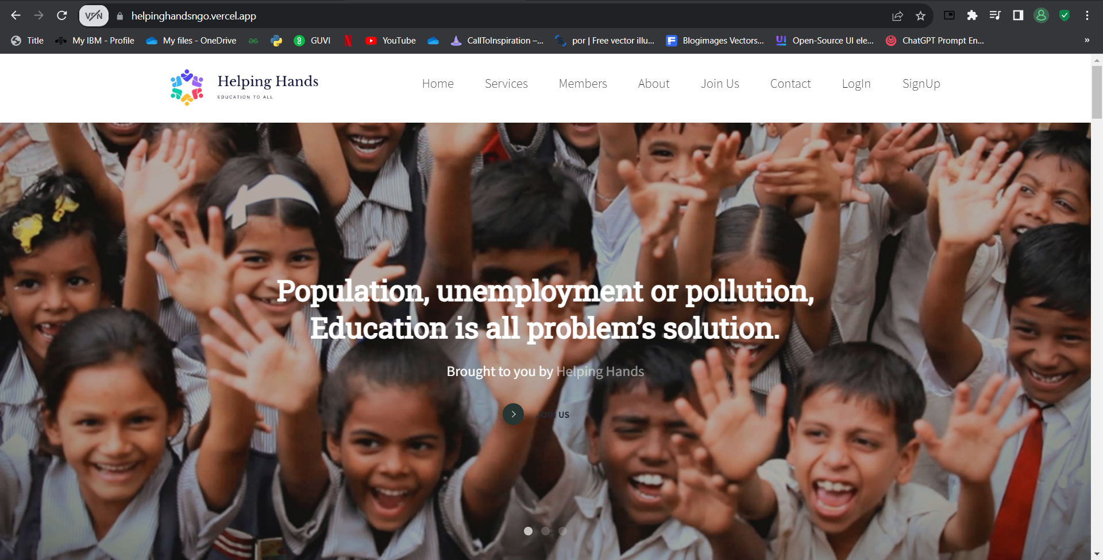

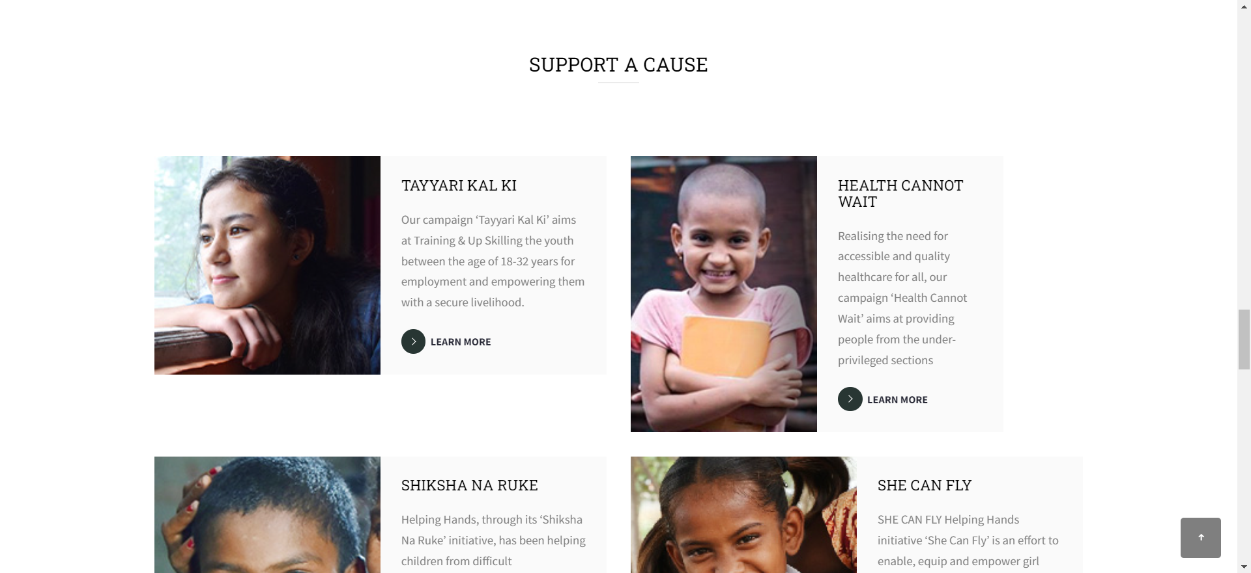

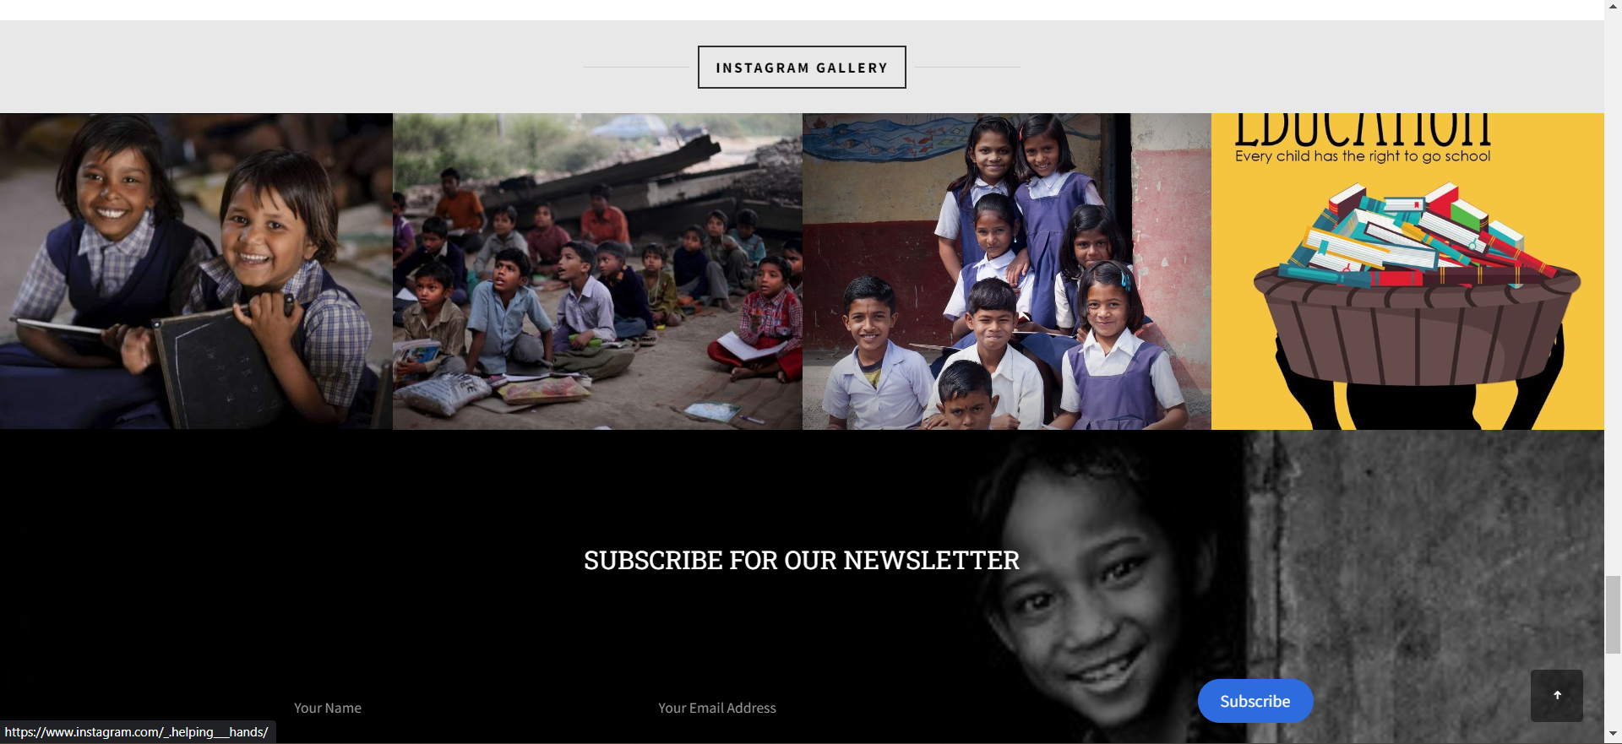

**Login page**

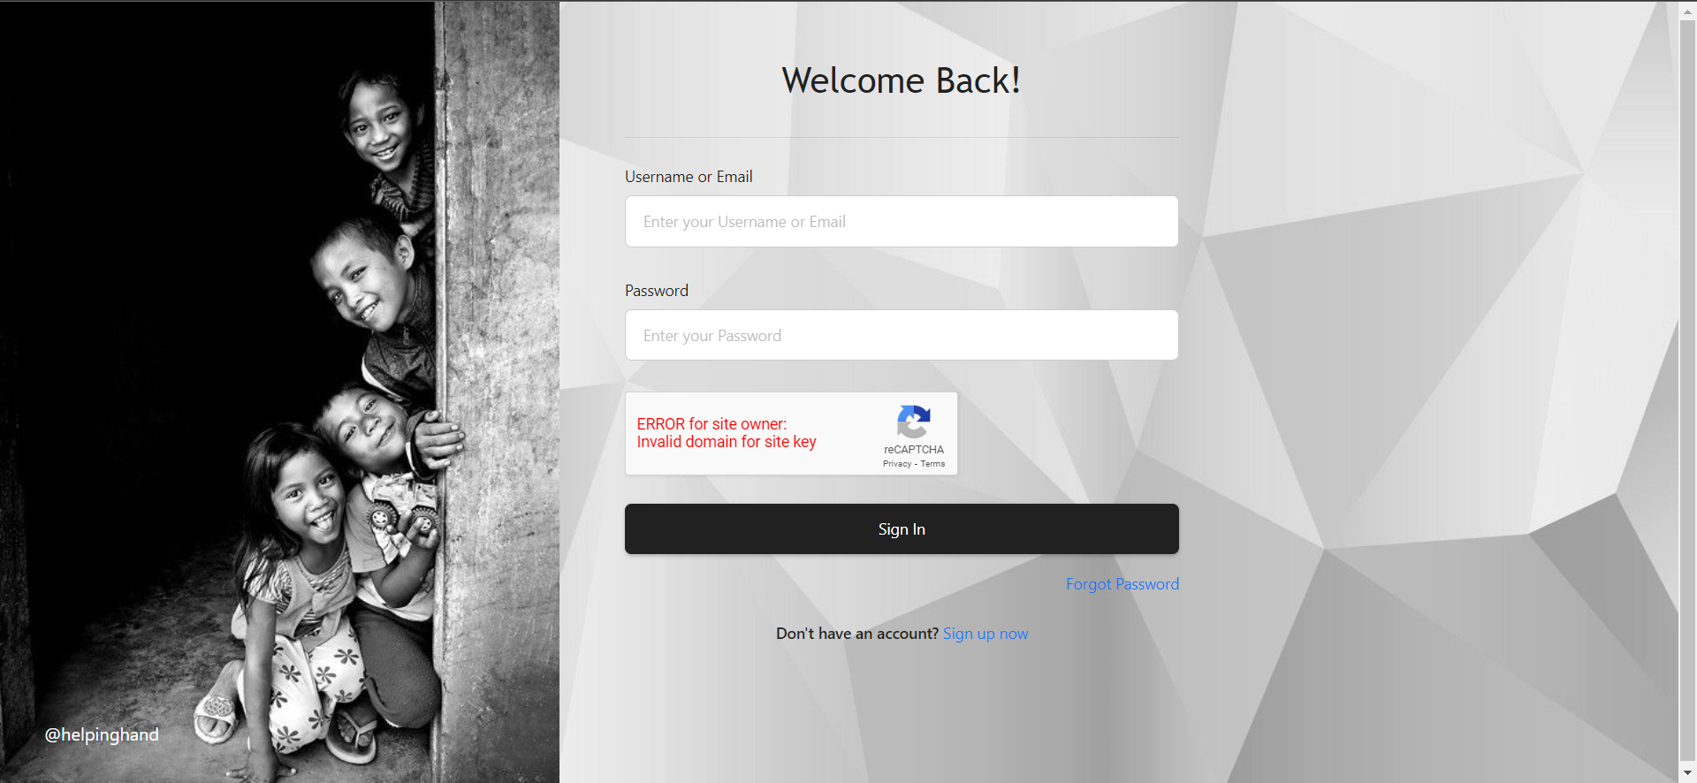

**Register page**

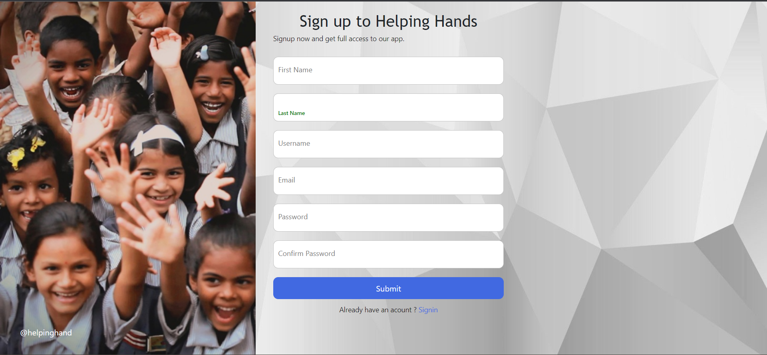

**Services**

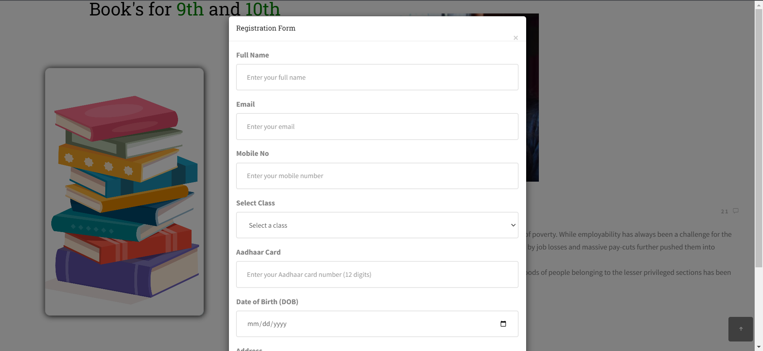

**Members**

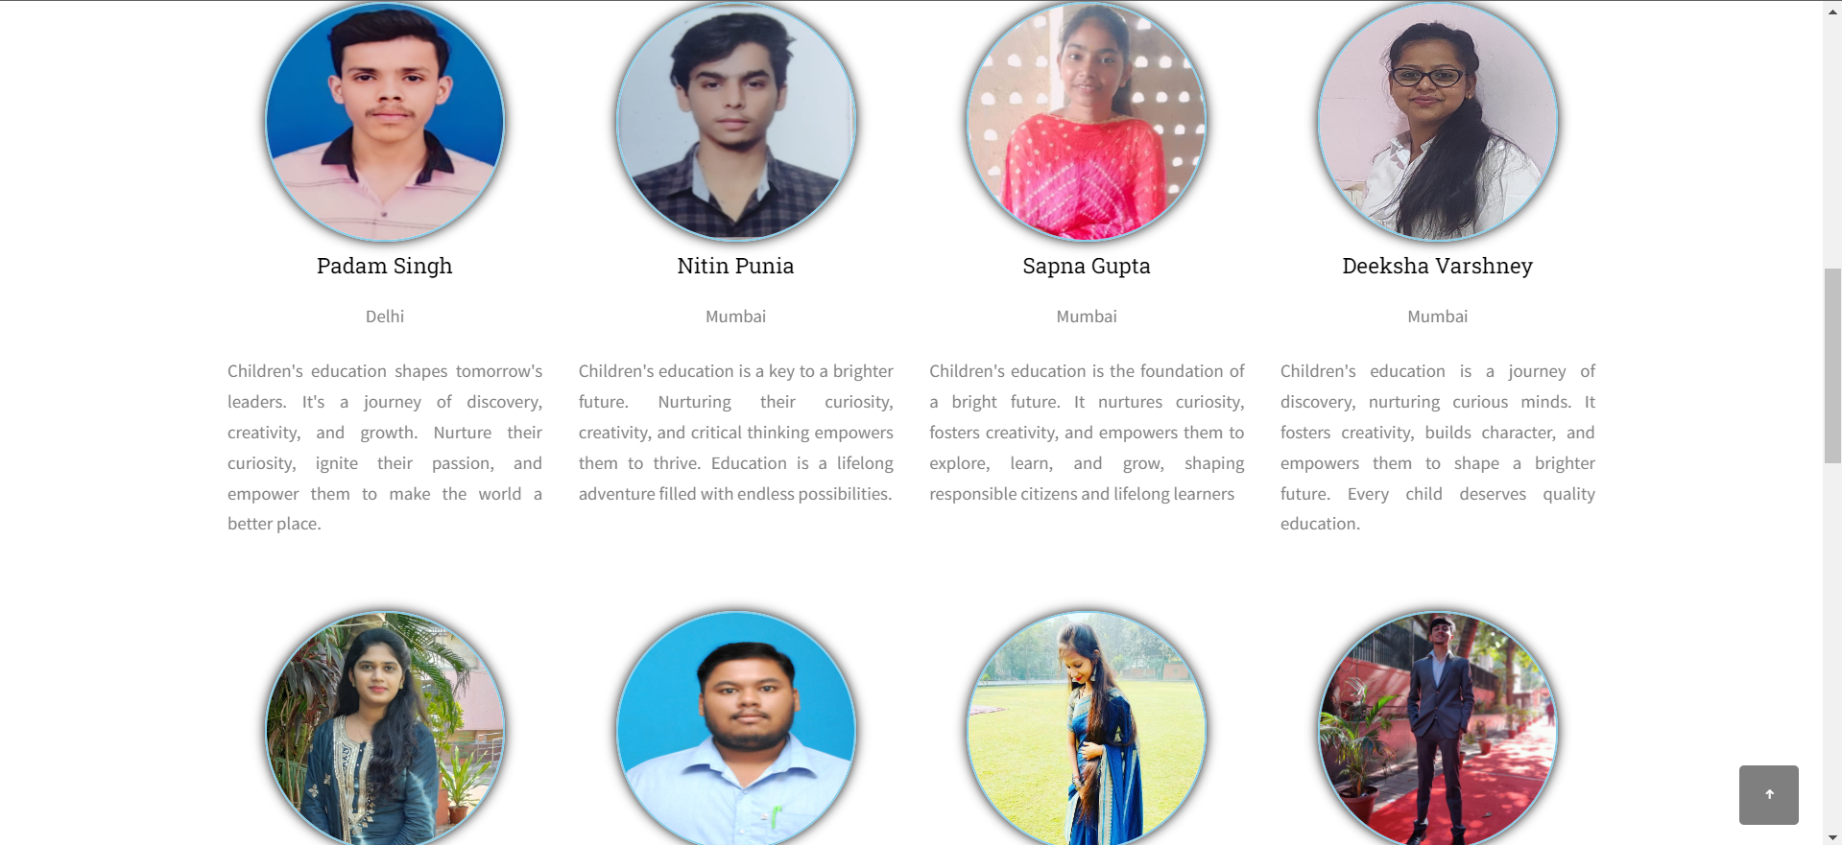

**About**

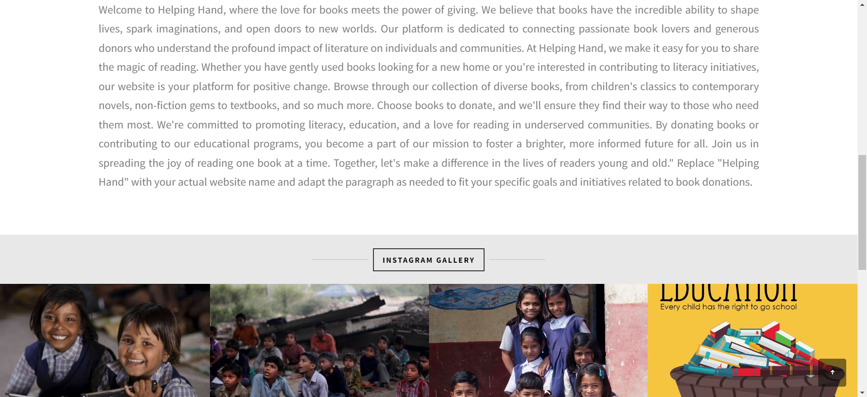

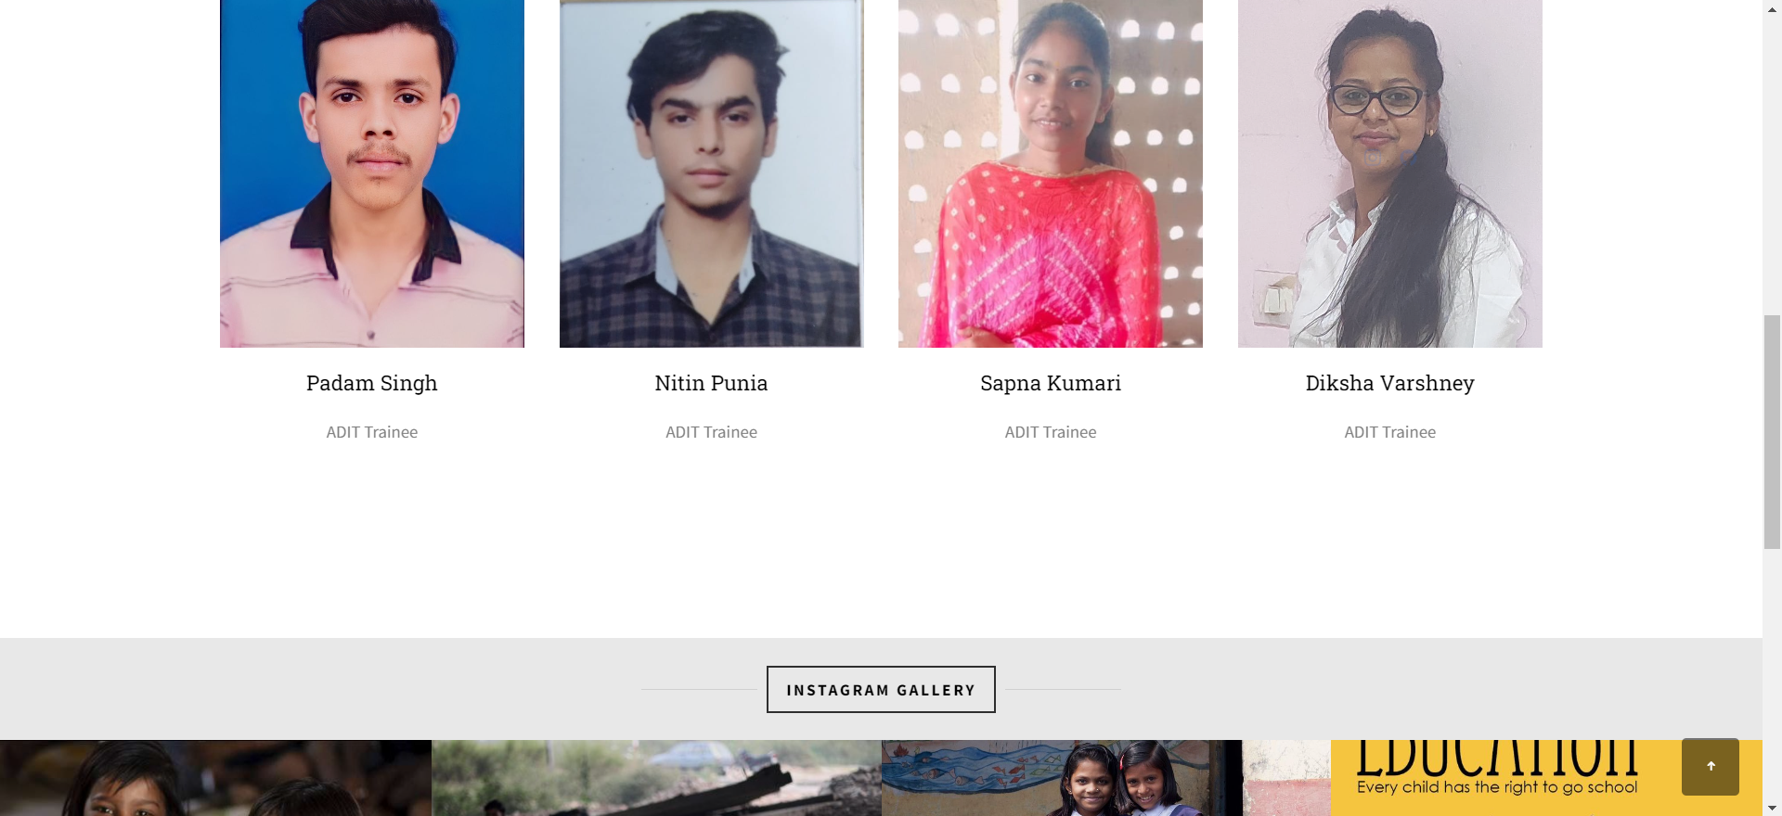



**Join Us**

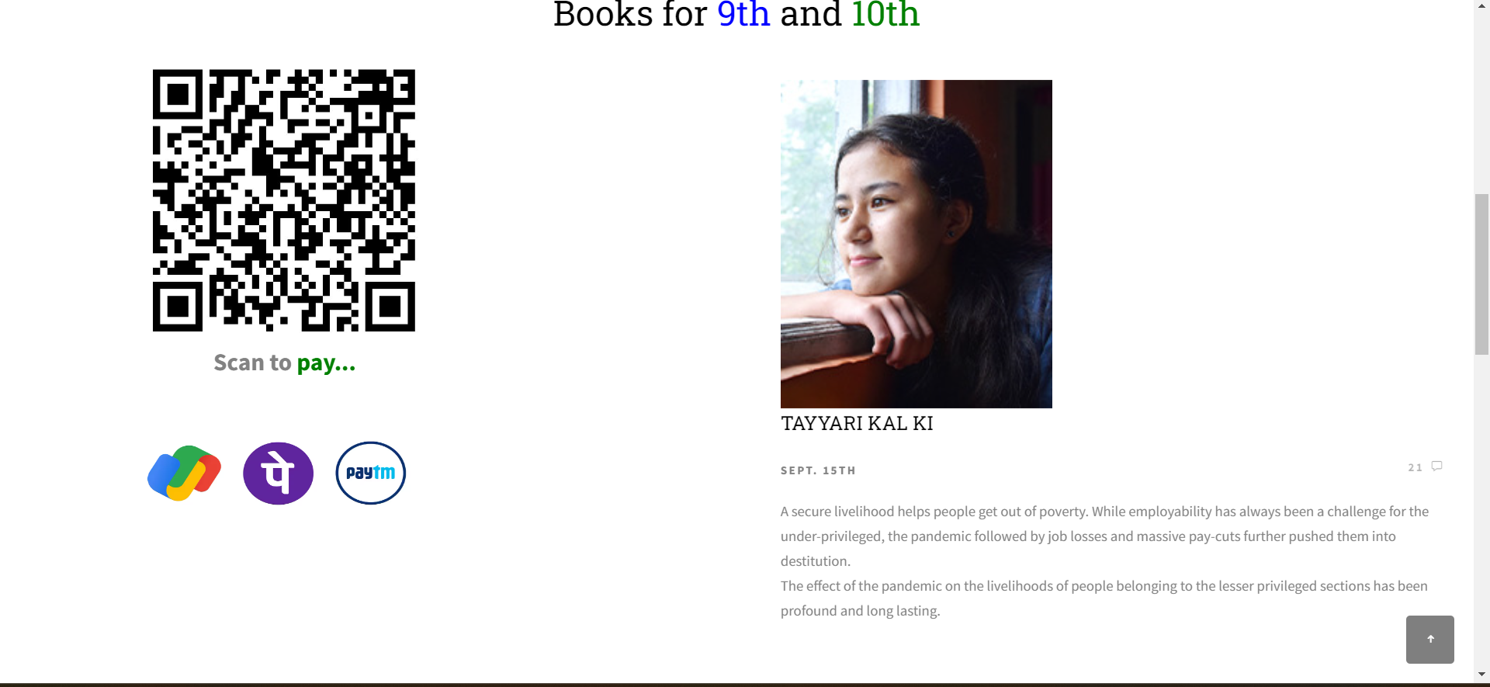

**Contact**

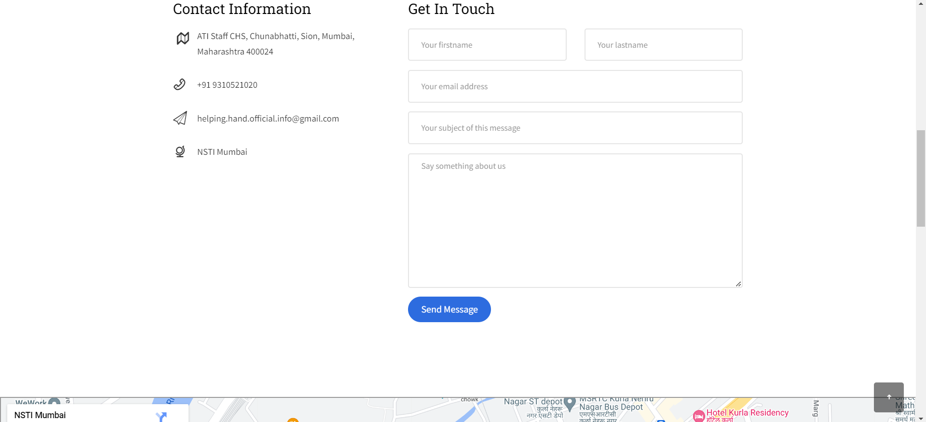

# Appendix C

## Abbreviation

HTML – Hypertext Markup Language

CSS – Cascading Style Sheet

JS – JavaScript

Pwd – Password

fname – firstname

lname – lastname

# References

[1] <https://docs.djangoproject.com/en/4.2/>

[2] <https://www.python.org/>

[3] <https://pylessons.com/django-introduction>

[4] <https://youtu.be/TFHeCBU71uk?si=B_Vh0LNE0eEUKlYY>

[5] <https://www.w3schools.com/django/>

[6] <https://vercel.com/dashboard>

[7] <https://railway.app/>

[8] <https://www.w3schools.com/django/django_db_create_rds.php>

[9] <https://www.w3schools.com/django/django_add_static_files.php>

[10] <https://www.pexels.com/search/indian%20culture%20images/>

[11] <https://www.flaticon.com/>